CSE325

(Team Number)

(12BCE0105, 12BCE0552, 12BCE0603)

Software Requirements Specification

Document

SUBMITTED TO:
PROF. LYDIA JANE G

Version: (1) Date: (23/2/2015)

Table of Contents

1. Introduction 3
1.1 Purpose 3
1.2 Scope 3
1.3 Definitions, Acronyms, and Abbreviations 3
1.4 References 3
1.5 Overview
2. The Overall Description 4
2.1 Product Perspective 4
2.1.1 System Interfaces 5
2.1.2 Interfaces 5
2.1.3 Hardware Interfaces 6
2.1.4 Software Interfaces 6
2.1.5 Communications Interfaces 6
2.1.6 Memory Constraints 7
2.1.7 Operations 7
2.1.8 Site Adaptation Requirements 7
2.2 Product Functions 8
2.3 User Characteristics 8
2.4 Constraints 8
2.5 Assumptions and Dependencies 9
2.6 Apportioning of Requirements
9
3. Specific Requirements 9
3.1 External interfaces 10
3.2 Functions 11
3.3 Performance Requirements 11
3.4 Logical Database Requirements 12
3.5 Design Constraints 12
3.5.1 Standards Compliance 12
3.6 Software System Attributes 12
3.6.1 Reliability 12
3.6.2 Availability 12
3.6.3 Security 12
3.6.4 Maintainability 12
3.6.5 Portability 12
3.7 Organizing the Specific Requirements 12

1. Introduction

We intend to develop a game Who am I? and a tic-tac toe game.In the who am I? game the player is asked to think of a famous celebrity. A set of questions is then asked and based on the responses, the celebrity is guessed by the software.In the game of Tic-TacToe, one of the players is allowed to login to the software so that he knows all the possible strategic moves to his opponent’s moves and hence will always win. We take the opponent to be the computer.

1.1 Purpose

The purpose of both these games is fun and entertainment of the user.User can simply play the games.The game is meant to be for all age groups.The software uses its knowledge of guessing which inturn makes the game an amazement for the player.Its fully a fun-purpose game. It gives user always a win-win situation in the tic-tac-toe game.

1.2 Scope

- Design a databse containing the information about all the celebrities.
- Use of html,javascript and css inorder to develop webpages of the games we intend to develop.
- The software is portable and can be used anywhere.
- Who am I ?-In this game we need to make the users surprise with accurate answers.
- Tic-Tac Toe-In this the user knows all the possible strategic moves to his opponent’s moves and hence always wins.

1.3 Definitions, Acronyms, and Abbreviations.

SRS: Software Requirements Specification
HTML: Hyper Text Markup Language

1.4 References

(1) http://en.wikipedia.org/wiki/List_of_Indian_film_actors
(2) http://www.wired.com/2013/06/how-does-the-web-genie-work/
(3) http://ostermiller.org/tictactoeexpert.html

2. The Overall Description

(i) Who Am I?
The idea of this game originates from an European version of it to guess celebrities. The algorithms that have been plied include a binary search from a decision tree that contain the database of celebrities. The aim is to find the celebrity in at most 20 questions.
The domain of the database can include 2^20=1,048,576 possibilities. A unique combination of the 20 answers gives the name of the celebrity. The questions are designed such that the combination of answers is unique.
It is a time-killer application that targets users of any age group for entertainment purpose.

(ii) Tic Tac Toe
This is a well-known game played between 2 players in a 3x3 grid. However,making only one player win always is the task of the application.
The domain of the game covers all the possible combinations of 0’s and x’s.
It is a game designed for users of all age groups.

2.1 Product Perspective

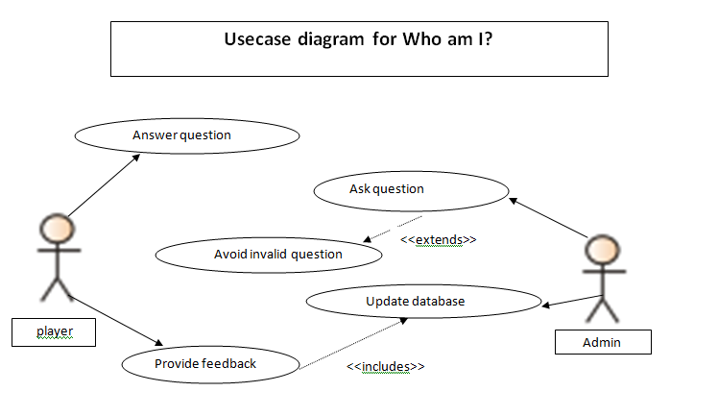

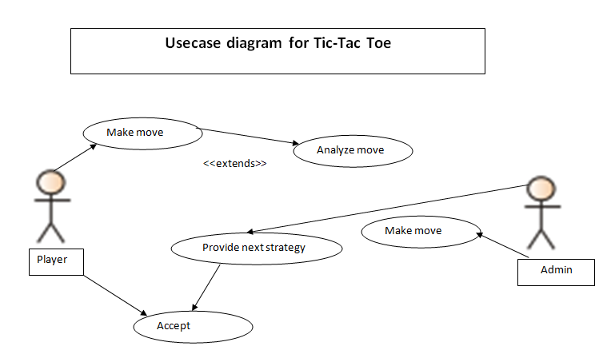

2.1.1 System Interfaces

The system interfaces of both the games are mentioned below:
- WHO AM I? :-
This game is highly interactive , and keeps the user occupied and involved in the game. Here the player thinks of a celebrity,asked a set of questions and the software gueses the celebrity.This way the player never looses the ineterst in the game and the software is highly attractive and accurate which makes it interesting to play.Wide range of options are available in the game,incase of if a celebrity is missing in the database,the user is able to add celebrities in the database.
- TIC TAC TOE :-
This game is quiet popular among all the people and played between two people.Our software covers all the possible combination of 0’s and X’s and it has highy attractive front end.This game is meant for all age groups and it always allows the user to win the game and not the computer or any other non- registered players.

2.1.2 Interfaces

- The logical characteristics of each interface between the software product and its users.
- All the aspects of optimizing the interface with the person who must use the system

1)WHO AM I? :-
The game allows the players to register,interact with the software.The user can play the game and in case the software fails to identityfy the celebrity,the user can always add a celebrity to the database of the software.The user can even view all the list of celebrities available in the databse of the software.It is highy a user-friendly and fun-filled game keeps one interes.

2)TIC TAC TOE :-
In this game also the player can resgister and play the game.In this there is always win-win situation the player always wins the game.All the possible combination of the X’s and 0’s are covered.The computer never wins the game or any other non-registered user.This never looses the interest of the user and makes the user happy about his winning situation.

2.1.3 Hardware Interfaces

The logical characteristics of interface between the software product and the hardware components of the system. This includes configuration characteristics.Both the games are highly compatible and runs on Windows XP, Windows 7,Windows 8 and it will even work on the latest version of Windows 10 also.The games have been designed using the Windows 7 operating system.The games are highly compatible and work on any system.

2.1.4 Software Interfaces

The use of other required software products and interfaces with other application systems. Required software product, include:
- Client on Internet and Intranet:
-Web browser : Internet explorer 9.0,Google Chrome 40.0,Mozilla firefox
-Operating system : Windows 7
- Database Server : WAMP (Windows Apache MySQL PHP)
- Database Software : Oracle 11g
- Rational Rose Software 98
- Microsoft VISIO 2007

2.1.5 Communications Interfaces

The various interfaces to communications can be local network protocols. These are protocols you will need to directly interact with.That is,even if are off the server u can use local host servers.These protocols will need to interact direct with.While using a custom protocol to communicate between the systems,then designer will know what to design.If it is a standard protocol,then one can refer an existing document or RFC.The existing document has html files and Wamp server etc.

2.1.6 Memory Constraints

The system runs on 32- and 64-bit operating system and mostly 64-bit operating systems(including windows,linux etc) can either run on 32- or 64-bit.The memory limits depends mainly on the build,on windows version and on underlying OS version.

2.1.7 Operations
The normal and special operations required by the user are:
- Registration
- Play the game
- Add celebrities to database ( by the user also )
- View all the celebrities available in the database of the software.
- Data processing support function
- Backup and recovery

2.1.8 Site Adaptation Requirements

- Website access:
You can visit the website and resgister,telling us who you are and revealing any personal information.We are not liable for any direct or indirect damages which may result on accessing the website.
- User content:
All the content generated by user can be used by our software and stored in our database for purpose of anonymous statistics.

2.2 Product Functions

The software we inetend to develop on Who Am I? and Tic Tac Toe. In Who Am I ? game.the player is asked to think of a famous celebrity.A set of questions are asked,based on the users answers ,the celebrity is guessed by the software.This makes the software not only interactive but also gains the interest of the user.
In Tic Tac Toe, the palyer is allowed to login to the software so that the players knows all the possible strategic moves of his opponent’s moves and hence the player always wins the game.This makes the game quiet interesting as the player always wins the game.
Both the games are for fun and entertainment of the user.User can play the game.The game is also meant for all age groups.Guessing and using the knowledge makes both the games interesting and hold the interest of the player.Its a fully a fun-purpose game.

2.3 User Characteristics

The general characteristics of the users using the product included educational level, experience, and technical expertise.

Faced with an ever growing mass of information,today’s user need smart tools to help them find their way and get answers to their questions and their expectation.
Our software is dedicated to devising these future solutions that will organize information and make is available to everyone.

2.4 Constraints

These can include:
1)Who Am I ? :-
i) In this if the player plays n-times, the accuracy should be 80%.
ii) The questionnaire must be designed in a manner such that all the celebrities have a unique combination of answers to those questions.

2) Tic Tac Toe :-
i) The the user always have a win-win situation, i.e the user always wins from the computer.
ii) Tie situations must be avoided.

2.5 Assumptions and Dependencies

1.Who am I?
- Number of questions: Fewer the number, lesser is the data that can be stored in database.
- In case the user does not wish to add a new celebrity, we assume that the user has to imagine a celebrity given in the database only.
- Users must know all the answers about the celebrity they imagine.
- Unknown, ordinary people cannot be searched in the game.

2.Tic Tac Toe
- User must not deliberately try to lose.
- User knows the game rules.

2.6 Apportioning of Requirements.

1.Who am I?
The list of celebraties is huge,so to get the answer correctly is the main purose of the software.There are n- number of questions, we can add 2^n of celebrities in the database.It not possible for us to adopt artificial intelligence in our software so we made a database of celebrities and limited our number of celebrities.So, the user has to guess among the given database.

2.Tic Tac Toe
Inorder to make the user win, the computer must know all the possible strategies of the user and always make an opposite move in accordance to the users move,so that the player will always win.

3. Specific Requirements

3.1 External Interfaces

3.1.1 Who Am I?
- Description of purpose : Entertainment and fun game for all age groups
- Source of input : Real Life Celebrities
- Valid range, accuracy and/or tolerance : Minimum 80%
- Data formats: Html
- Command formats : commands for connection through php,mysql
3.1.2 Tic-Tac-Toe
- Description of purpose : Entertainment and fun game for all age groups
- Source of input : Rules of Game
- Valid range, accuracy and/or tolerance : Minimum 80%
- Data formats: Html
- Command formats : javascript

3.2 Functions

Functional requirements define the fundamental actions that must take place in the software in accepting and processing the inputs and in processing and generating the outputs.
Following are the functional requirements for the games: (I.D.s are provided for priority)
i) WHO AM I?
- Attractive front end(4)
As a user, I would like the display page to be colorful and attractive.
- Accuracy(1)
I would like each of the celebrities I think of to be correctly identified. Only such a game will make itself interesting to play.
- Wide range of options(2)
The celebrities available in the game should be of a wide range.
(The database should be huge and correct.)
- Feedback Provision(3)
In case, a celebrity is not available in the database, I should be able to suggest the addition into the database.
ii) TIC TAC TOE
- Attractive front end(2)
As a user, I would like the display page to be colorful and attractive.
- WIN-WIN SITUATION(1)
The game should always allow me to win the game and not the computer or the other non-registered player.
(This step is tedious itself and requires all cases from a user’s view to be considered for a win.)

3.3 Performance Requirements

Performance is measured in various parameters.
- Usability requirement:- The system must be running 95% of the time.
- Reliability Requirement :-The system must support parallel tournaments.
- Performance Requirement :-The operator must be able to add new games without modifications to the existing system.
- Supportability requirement :- The software should be supported by all different operating systems.
- Portability requirement:- the software is portable and can be used anywhere.

3.4 Logical Database Requirements

Who Am I ? has two tables in the database: Users and Whoami.
3.4.1 Users
It lists the users of the game. It contains
- Name
- Age
- Password
- searched celebrity.
3.4.2 Whoami
It contains the following attributes:
- id int
- name varchar(20)
- gender varchar(1)
- profession varchar(15)
- marital varchar(1)
- dead varchar(1)
- nationality varchar(1)
- religion varchar(1)
- cartoon varchar(1)

3.5 Design Constraints

None

3.5.1 Standards Compliance

None

3.6 Software System Attributes

3.6.1 Reliability

Reliability of the software system at time of delivery will be high. System crashes are expected to be low in the initial stages since database is not highly populated as compared to later stages. Tic-Tac-Toe assures to be reliable as compared to Who Am I?

3.6.2 Availability

The games will be available 24x7.

3.6.3 Security

Registration and authenticated login will ensure protection from accidental or malicious access, use, modification, destruction, or disclosure. It also includes securing the database with a password that is never revealed to the user.

3.6.4 Maintainability

The Who Am I? requires high maintainability since it requires addition of new celebrities every time the user does not find it in the database.

3.6.5 Portability

ID | Characteristic | H/M/L | 1 | 2 | 3 | 4 | 5 | 6 | 7 | 8 | 9 | 10 | 11 | 12
1 | Correctness | H
2 | Efficiency | H
3 | Flexibility | H
4 | Integrity/Security | H
5 | Interoperability | H
6 | Maintainability | H
7 | Portability | M
8 | Reliability | M
9 | Reusability | M
10 | Testability | L
11 | Usability | L
12 | Availability | L

Definitions of the quality characteristics not defined in the paragraphs above follow.

• Correctness - extent to which program satisfies specifications, fulfills user’s mission objectives
• Efficiency - amount of computing resources and code required to perform function
• Flexibility - effort needed to modify operational program
• Interoperability - effort needed to couple one system with another
• Reliability - extent to which program performs with required precision
• Reusability - extent to which it can be reused in another application
• Testability - effort needed to test to ensure performs as intended
• Usability - effort required to learn, operate, prepare input, and interpret output

3.7 Organizing the Specific Requirements

Fun games is basically for playing entertainment games. This has two parts included in it . They are : Who am i? and the next is Tic Tac Toe.
WHO AM I?
It has only four functions like register , play the game,add any new character and last view online all the characters.This would not need any of the requirements like system mode,objects or classes.
Tic-Tac-Toe
In this game we can play the game such that always the computer will be losing and user must be winning. It does not require system mode,objects or classes.

